**Aim:**

To execute basic Perl programs

**Description:**

ARRAYS IN PERL:

An array is a variable that stores an ordered list of scalar values. Array variables are preceded by an "at" (@) sign. To refer to a single element of an array, you will use the dollar sign ($) with the variable name followed by the index of the element in square brackets.

@ages = (25, 30, 40);

@names = ("John Paul", "Lisa", "Kumar");

print "\$ages[0] = $ages[0]\n";

print "\$ages[1] = $ages[1]\n";

print "\$ages[2] = $ages[2]\n";

print "\$names[0] = $names[0]\n";

print "\$names[1] = $names[1]\n";

print "\$names[2] = $names[2]\n";

ARITHEMATIC OPERATIONS OF PERL:

|  |  |
| --- | --- |
| **Sl.No.** | **Operator & Descriptio** |
| 1 | **+ ( Addition )**  **Example** − $a + $b will give 30 |
| 2 | **- (Subtraction)**  **Example** − $a - $b will give -10 |
| 3 | **\* (Multiplication)**  **Example** − $a * $b will give 200 |
| 4 | **/ (Division)**  **Example** − $b / $a will give 2 |
| 5 | **% (Modulus)**  **Example** − $b % $a will give 0 |
| 6 | **\*\* (Exponent)**  **Example** − $a**$b will give 10 to the power 20 |

**QUESTION 1: Demonstrate various operators in perl.**

**PROCEDURE:**

1. Get choice from user for arithmetic, comparison, string, bitwise operation
2. If arithmetic operation then choice operation
3. Perform operation and print the value
4. If comparison operation
5. Enter 2 values
6. Check if values are equal or greater than or less than
7. Print the output
8. If string operation then enter two strings
9. Perform concatenation operation and print the result
10. If bitwise operation then enter two values
11. Perform bitwise &,|, <<, >> and print the value

**Output:**

Source Code

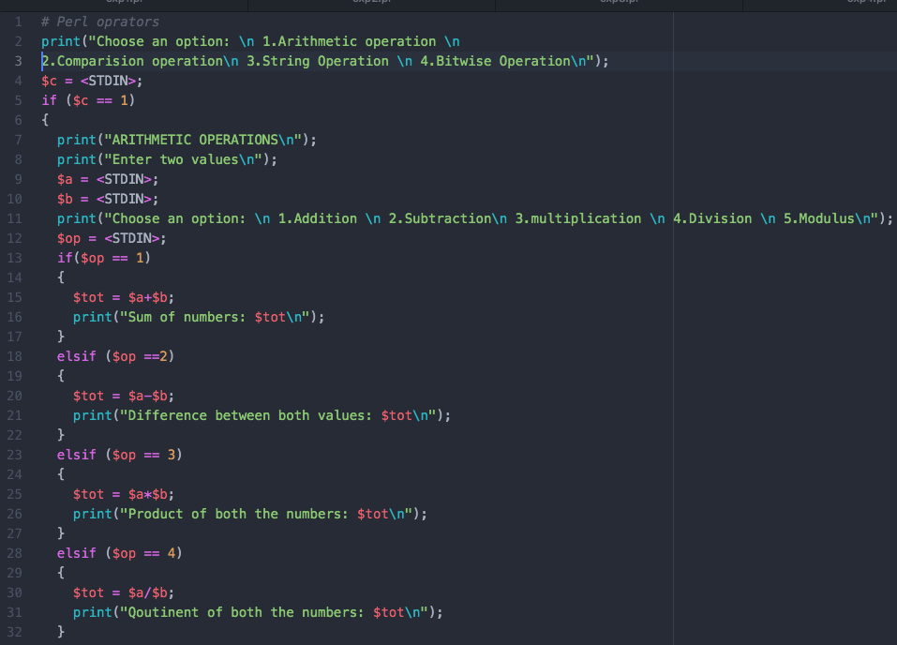

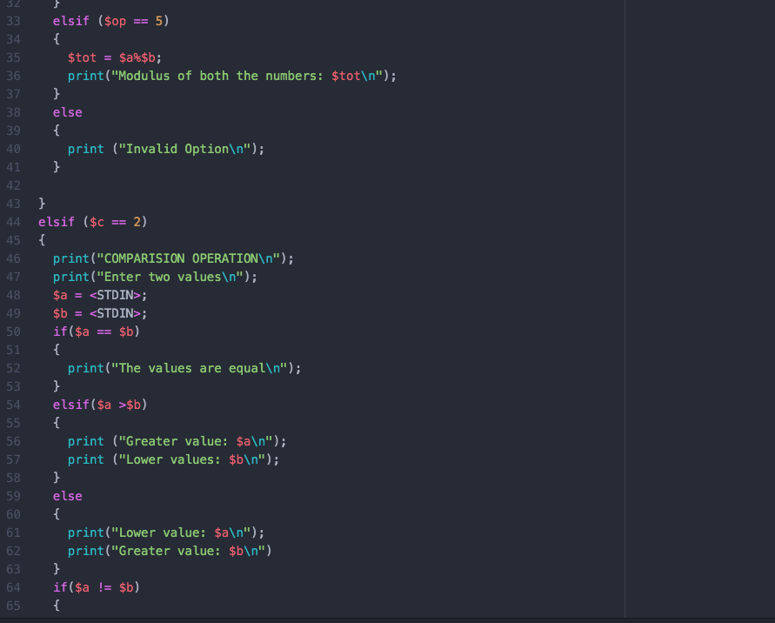

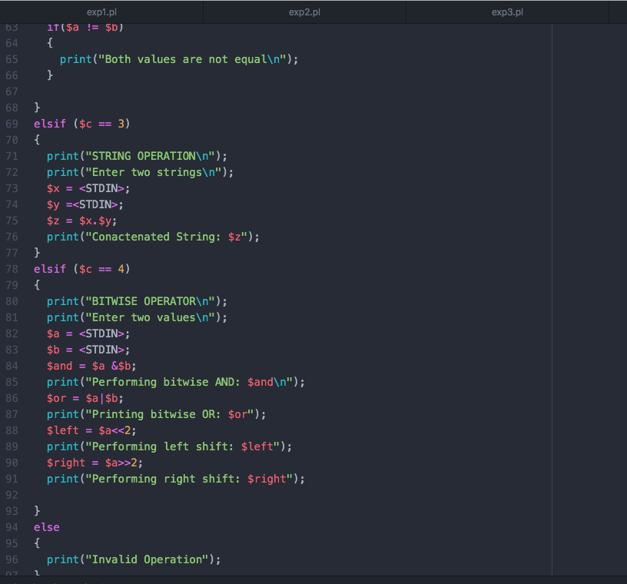

Output:

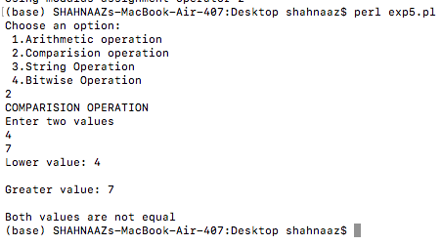

**QUESTION 2: Print 10 inputs received from the user.**

**PROCEDURE:**

1. Create a for loop that executes from 0 to 9
2. Input values into an array
3. Print the array

**Output:**

Source Code

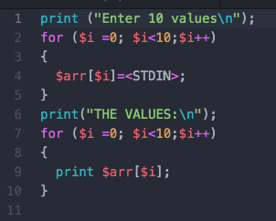

Output

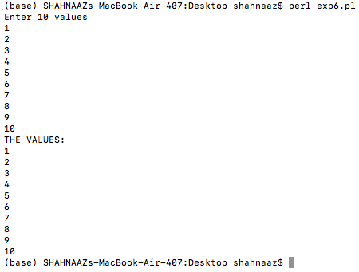

Video Link:

RESULT:

Basic perl programs are successfully executed.